**Project Name:**

**Development of a Global Engagement & Partnerships Office (GEPO) Website**

**Submission Date: 01/02/2025**

**Competition Name : JIS GEPO & RFMO Website Competition 2025**

**Team Name: Byte Coders**

**Members:**

**Sayan Bera**

**Bikram Koley**

**Parijat Dutta**

**Table of Content**

1. **Introduction ………………………………………………………………………….**
2. **Target Audience & Problem It Solves :………………………………………….**
3. **Technology Stack ………………………………………………………………….**
4. **Website Workflow Diagram (Flowchart/UI Navigation)……………………….**
5. **Working Flow with Screenshots …………………………………………………**
6. **Testing & Debugging………………………………………………………………**
7. **Future Improvements & Scalability………………………………………..**

**1. Introduction**

The Global Engagement & Partnerships Office (GEPO) website is designed to serve as a comprehensive platform for managing and promoting international collaborations, exchange programs, and partnerships within the JIS Group. Its primary purpose is to enhance accessibility and streamline the management of global engagement initiatives, making it easier for students, faculty, and international partners to connect and collaborate.

Targeted towards students, faculty members, and potential international partners, the GEPO website offers a user-friendly interface that allows users to access vital information, resources, and opportunities related to global engagement. Key functionalities include sections dedicated to outlining study abroad programs, faculty exchange initiatives, and internship opportunities, as well as an interactive map showcasing global partners. This ensures that all stakeholders have easy access to information that can facilitate their engagement in international activities.

The website significantly enhances the management of research grant opportunities by providing a centralized system where users can explore available grants, submit proposals, and track the progress of their applications. The inclusion of features such as user registration, secure login, and an admin portal allows for effective oversight and management of all interactions, ensuring that inquiries and proposals are handled efficiently.

By fostering a collaborative environment and providing essential resources, the GEPO website not only simplifies the processes associated with international partnerships but also promotes transparency and accountability in managing research grants. This strategic approach ultimately contributes to enriching the educational and research experiences of faculty and students alike.

The website includes:

* **Grant listings**
* **User registration & secure login**
* **Project proposal submission**
* **Real-time project tracking**
* **Admin portal for oversight & report generation**

The goal is to **streamline** the GEPO process, improve **transparency**, and **foster collaboration** across the institution.

**2. Target Audience & Problem It Solves :**

**Target Audience:**

* Faculty members (Researchers & Professors)
* Principals of institutions
* Administrators (RFMO Officials)
* GEPO Professionals

**Problems Solved:**

The GEPO website effectively addresses several key problems faced by its target audience:

•           **Simplification of Grant Applications**: By providing a user-friendly interface for submission and tracking, the website reduces the complexity typically associated with grant applications.

•           **Improved Transparency**: The platform ensures that all stakeholders have access to the same information, fostering trust and collaboration among faculty, principals, and administrators.

•           **Centralized Management System**: The website acts as a hub for all grant-related activities, allowing for better organization and oversight of research projects.

•           **Enhanced Collaboration**: By facilitating easy access to resources and opportunities, the website promotes partnerships and collaborative efforts among faculty and international institutions.

Overall, the GEPO website is a strategic solution that addresses the specific needs of its target audience while streamlining processes and promoting collaboration within the JIS Group.

**3. Technology Stack :**

**Frontend**

* HTML, CSS → For structuring and styling the user interface.
* JavaScript → Handles interactivity and dynamic content.

**Backend**

PHP → used for backend scripting.

MySQL → Manages structured data, including users, grants, and proposals.

**3. Website Workflow Diagram (Flowchart/UI Navigation)**

Workflow of this GEPO website can be divided into 3 sub parts.

1. Admin side
2. Partner side
3. Faculty side

**i.admin side :**

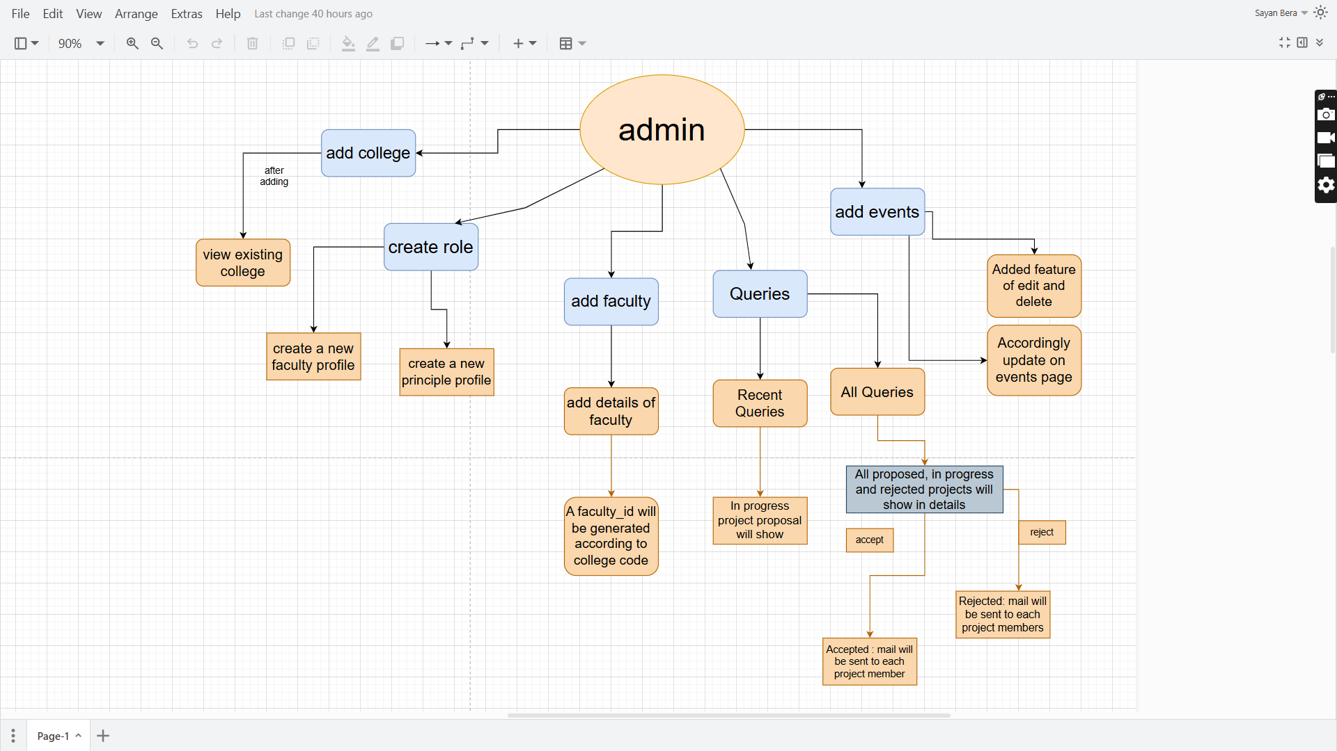

**ii.partner side: can only inquiry send and see the progress.**

**iii.faculty side:**

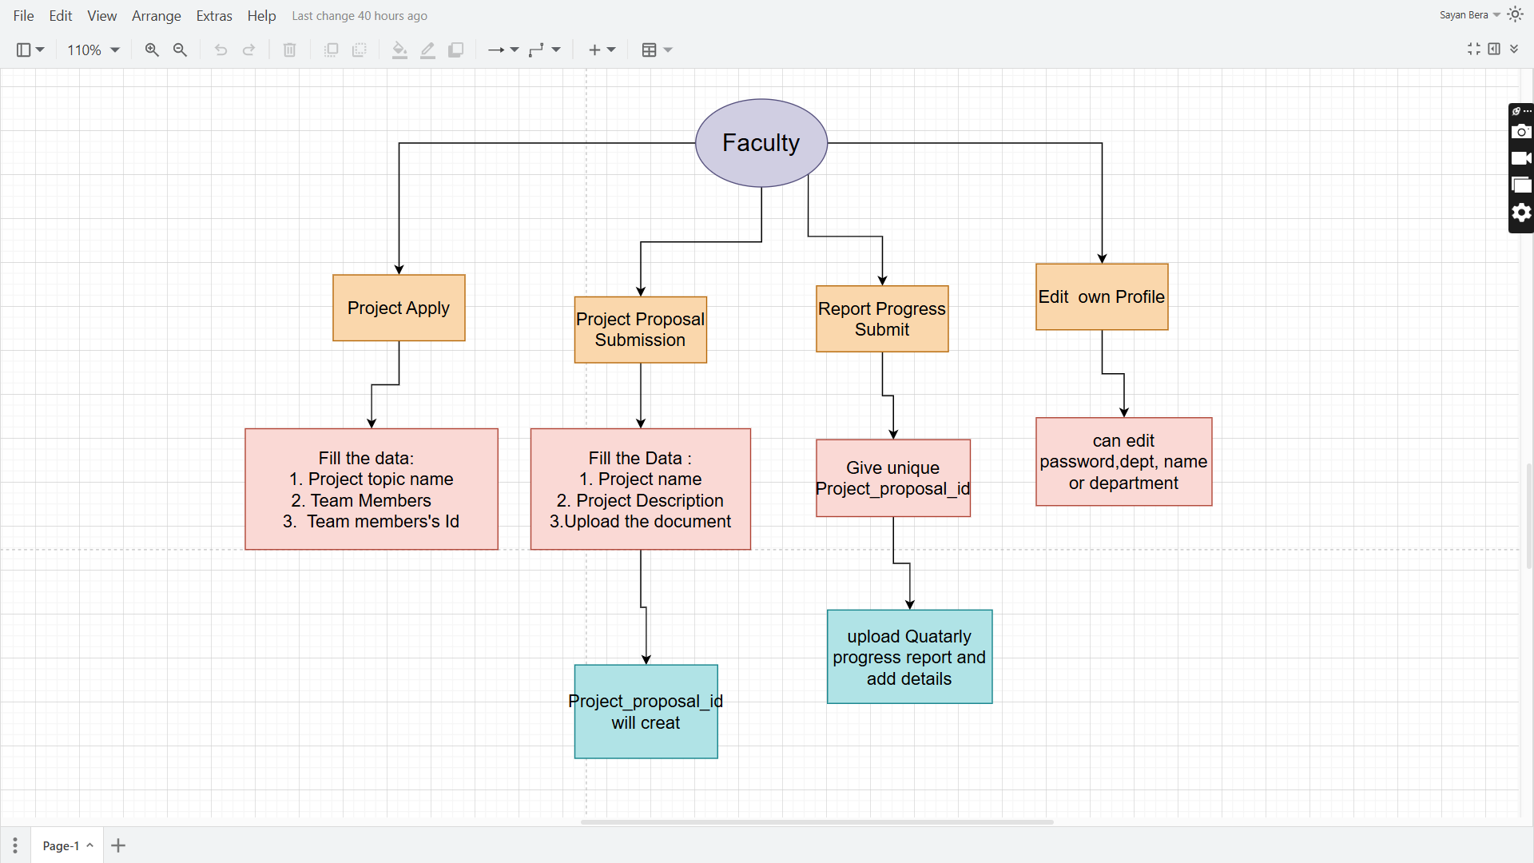

**4. Working Flow with Screenshots:**

**4.1.home page:**

home page contains

navbar including login button and logo and quick access link

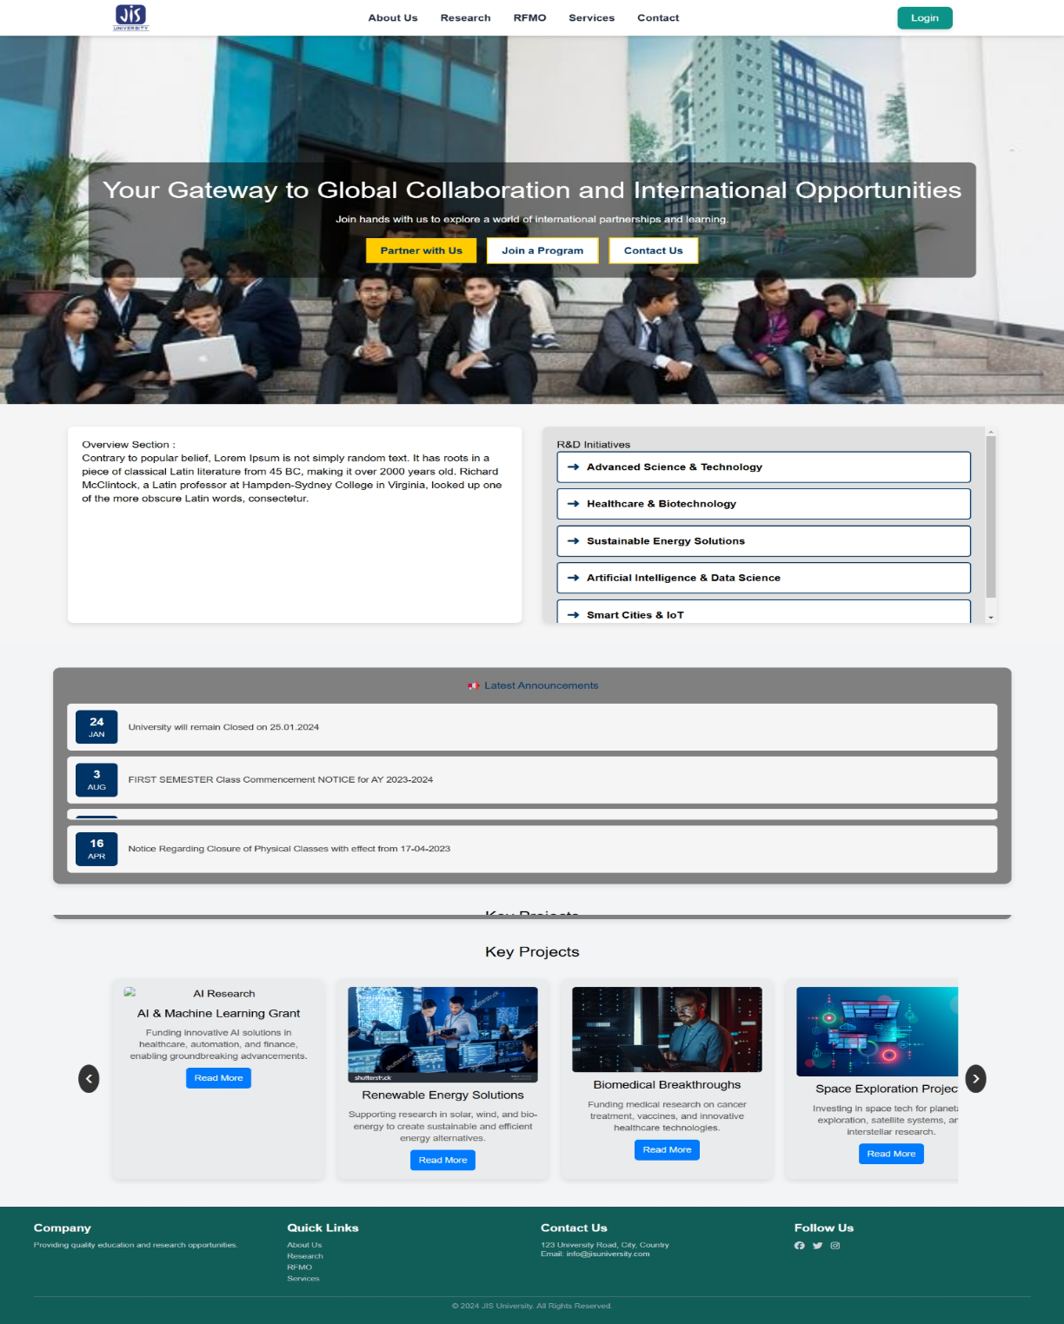

**4.1.login page:**

This page contains three types of login system

1. Admin login
2. Partner login
3. Faculty login

Along with OTP verification feature

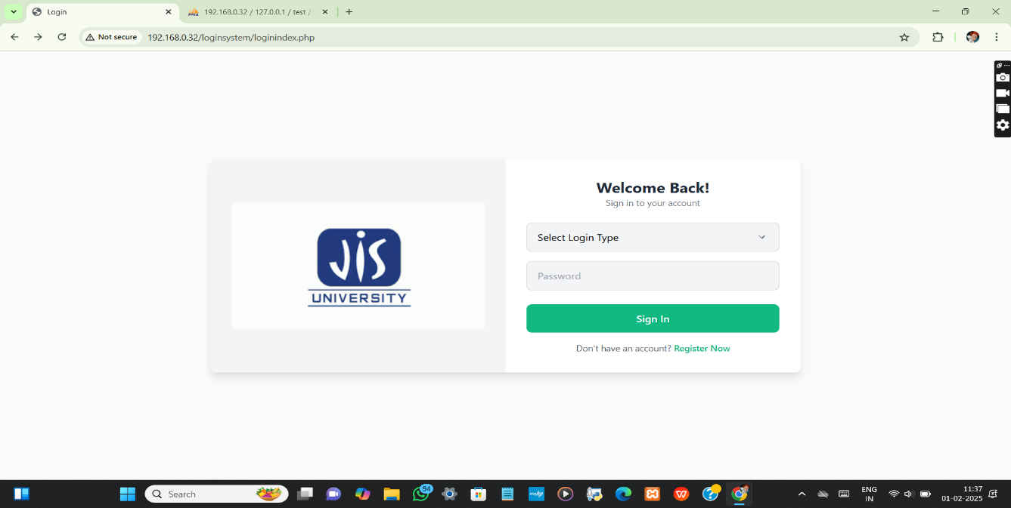

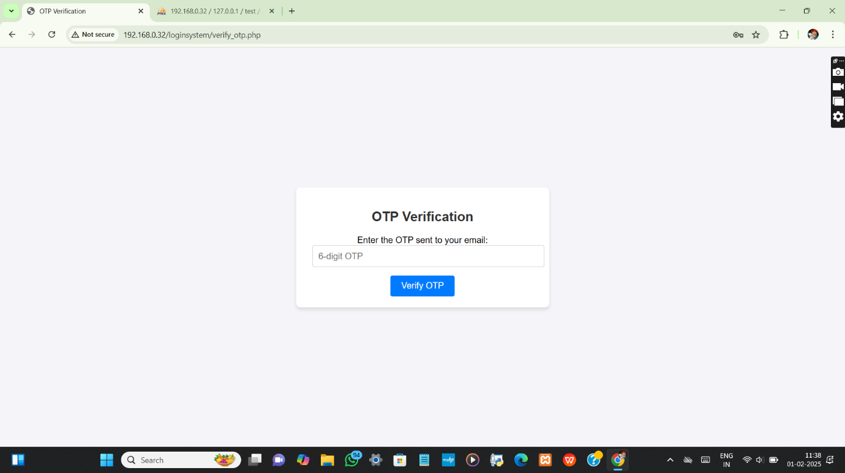

**4.1.1. Admin login page:**

After logging into as admin admin dashboard will open including

1. Add college
2. Create role
3. View existing college
4. Edit data
5. Add faculty
6. Recent queries
7. All queries
8. Add events
9. Inquiries
10. Project proposals
11. Progress reports

**1. Add college:**

Admin can manually add unique college code and college name in this section.

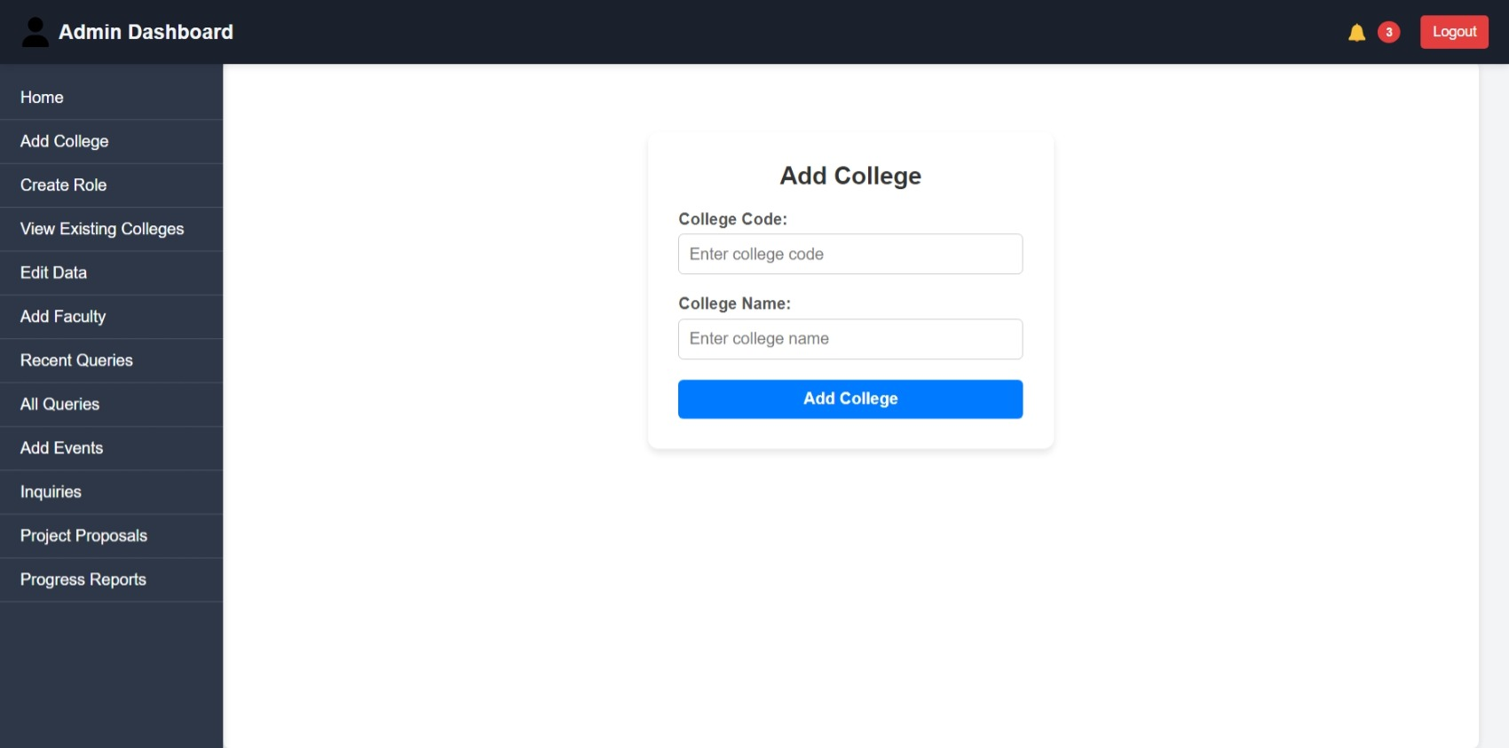

**II. Create Role :**

Admin can add new role – Faculty or Principle.

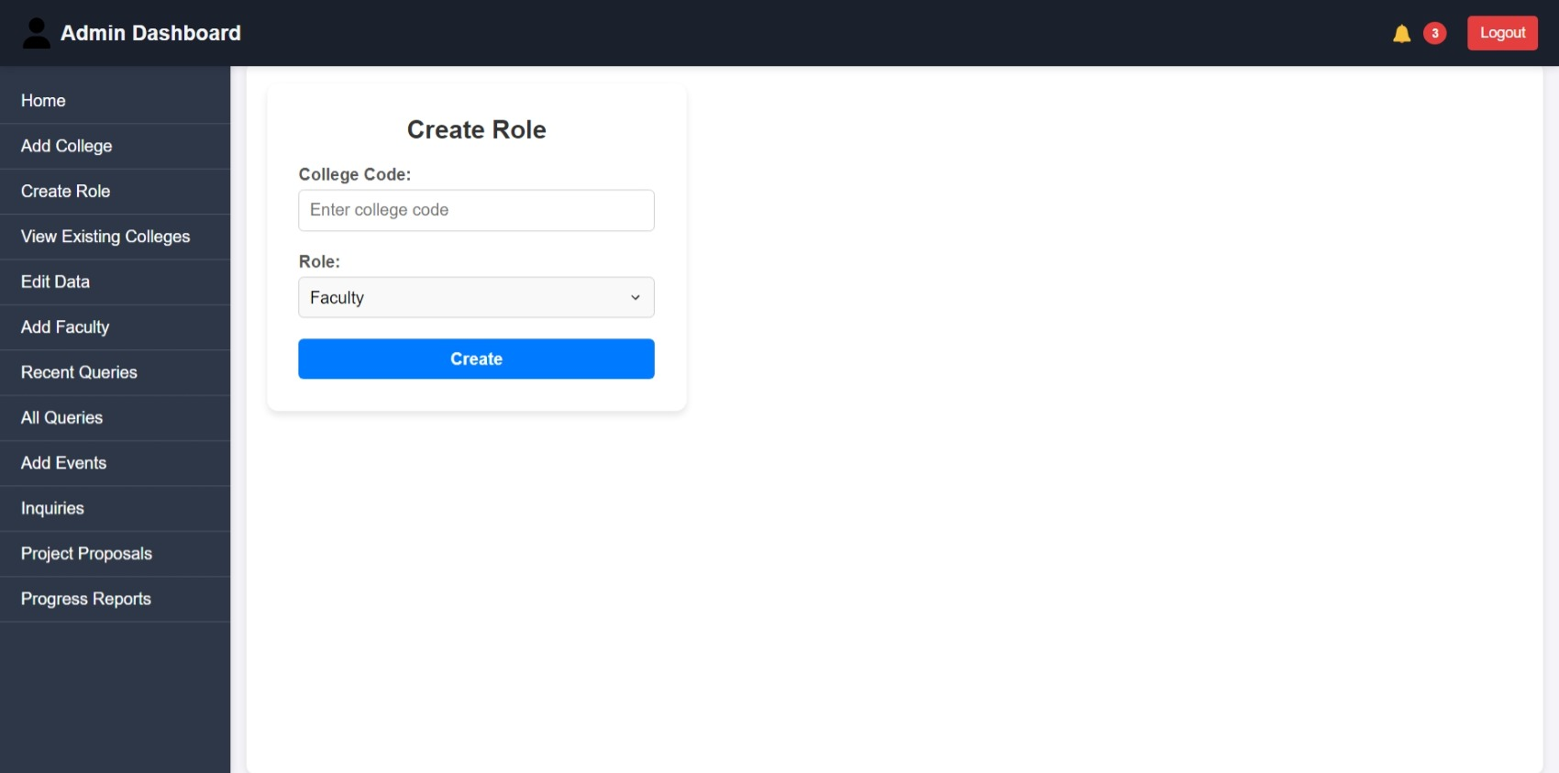

* Faculty or principal will be added according to the college table according to the corresponding college code.
* A unique id will be generated for each faculty.
* 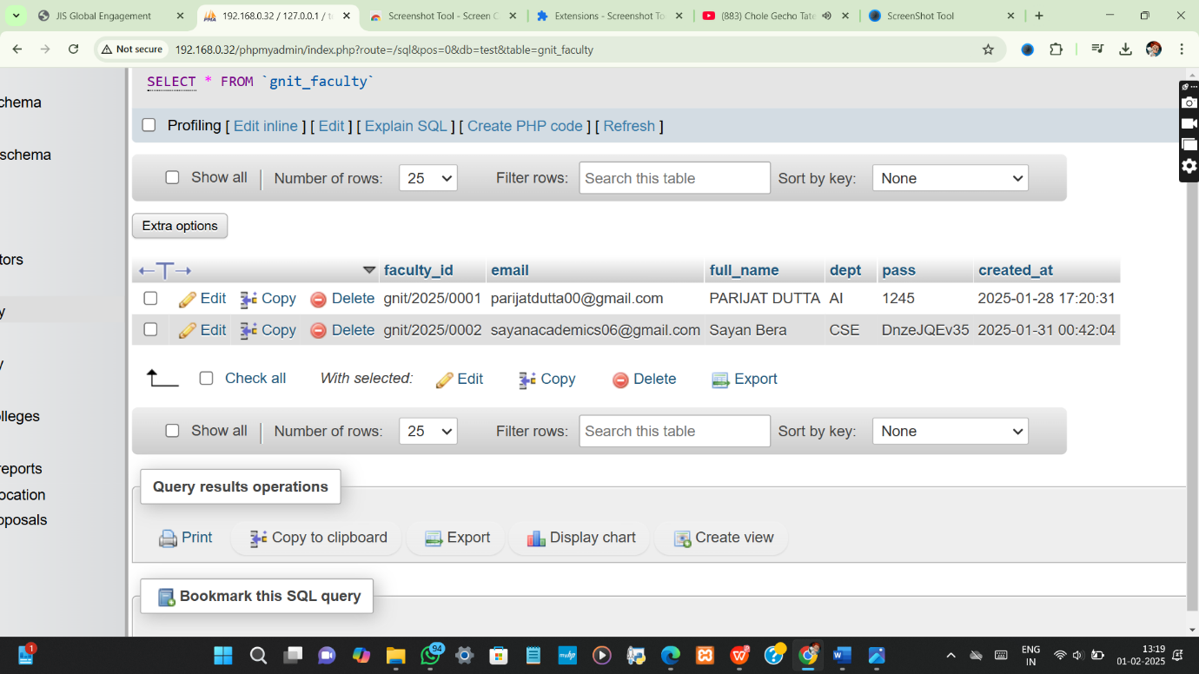

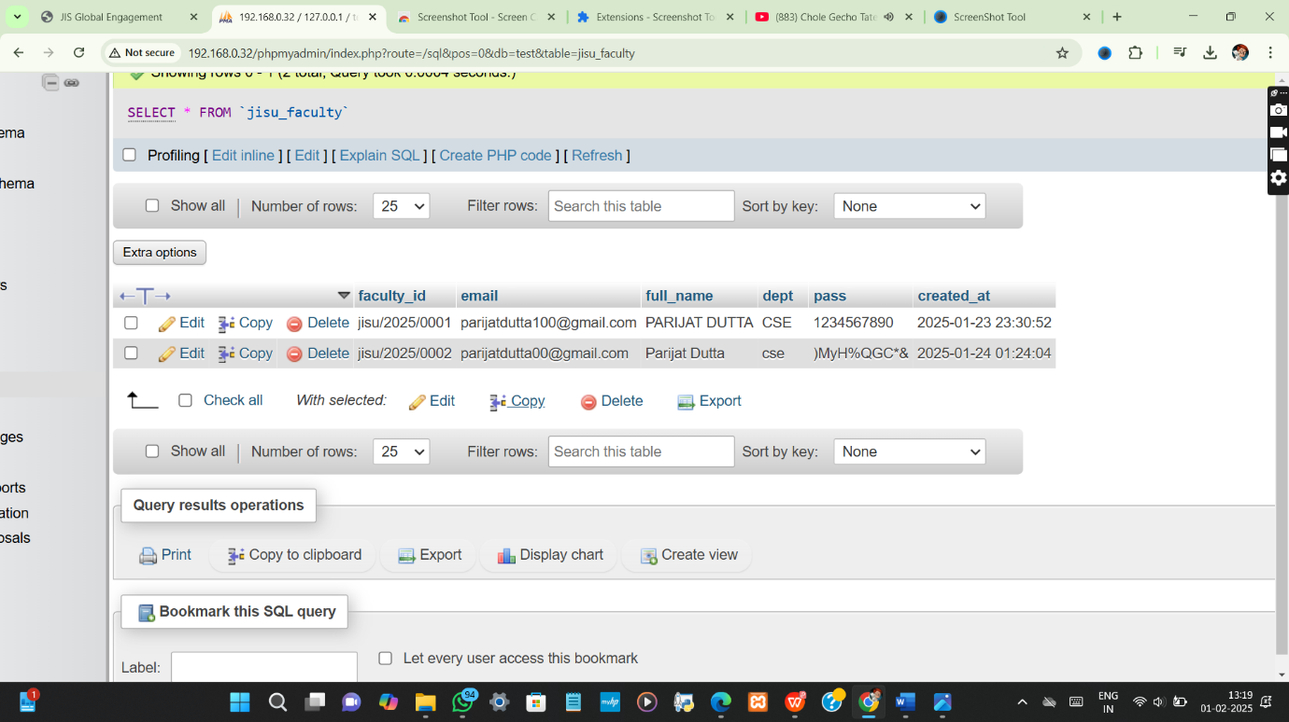

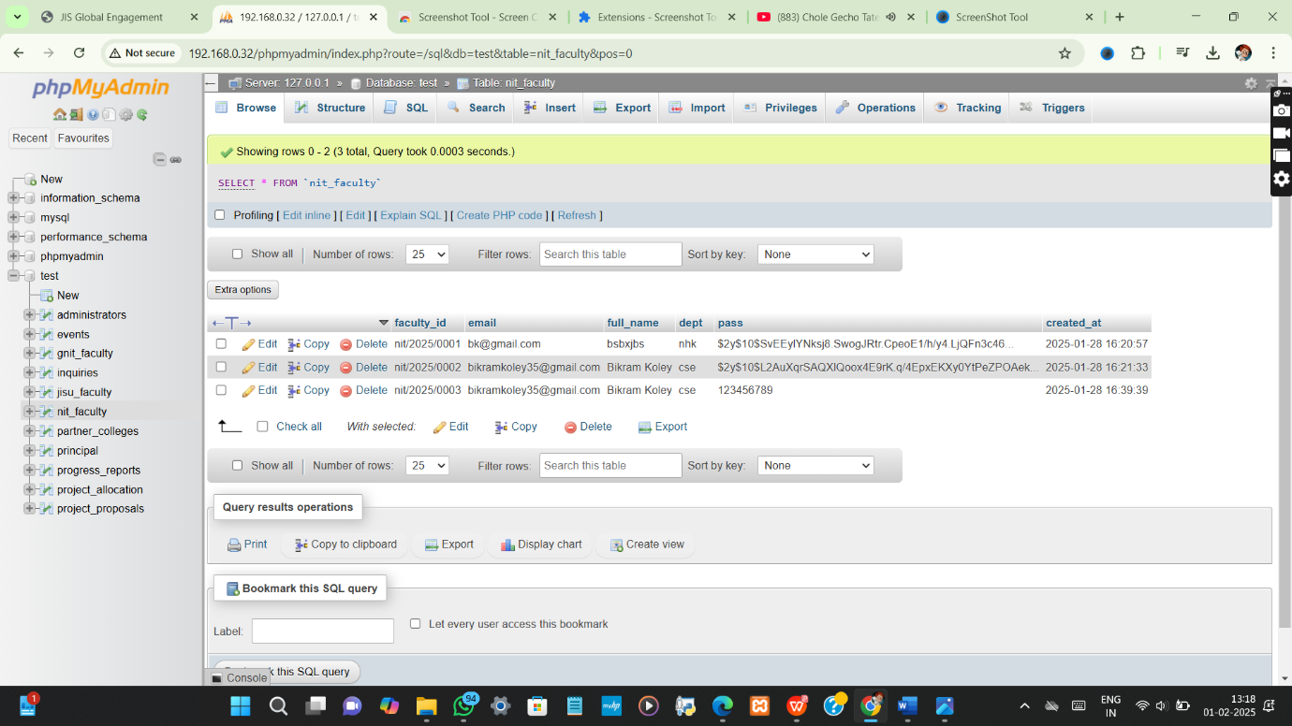

**III. View Existing College**

Added college by admin in “Add college Page” will be shown in “View existing college” with the corresponding college ID.

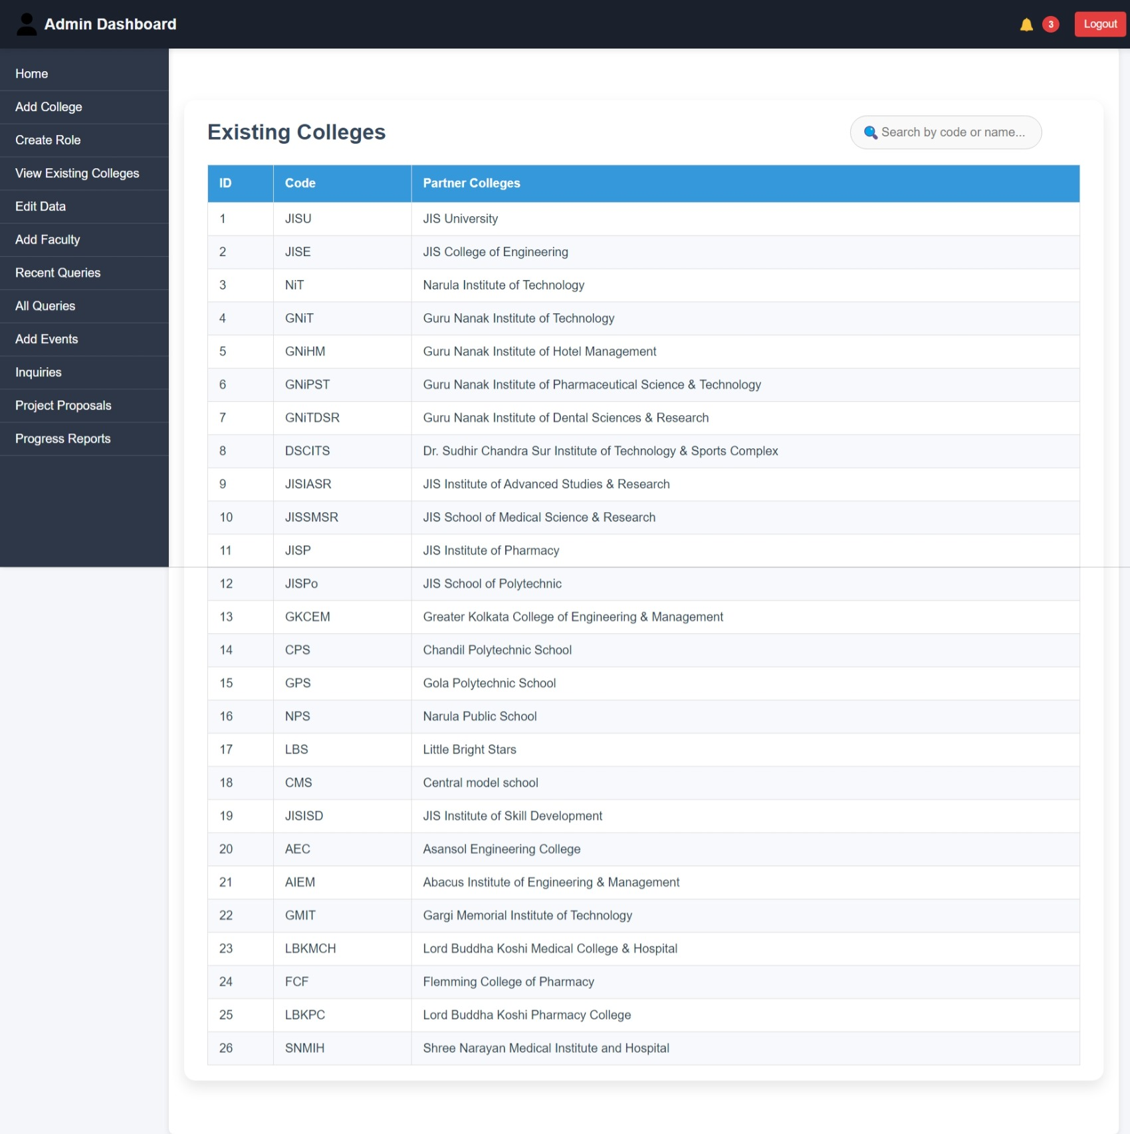

**IV. Edit data**

In this section already existing college data , faculty data & principal data can be edited.

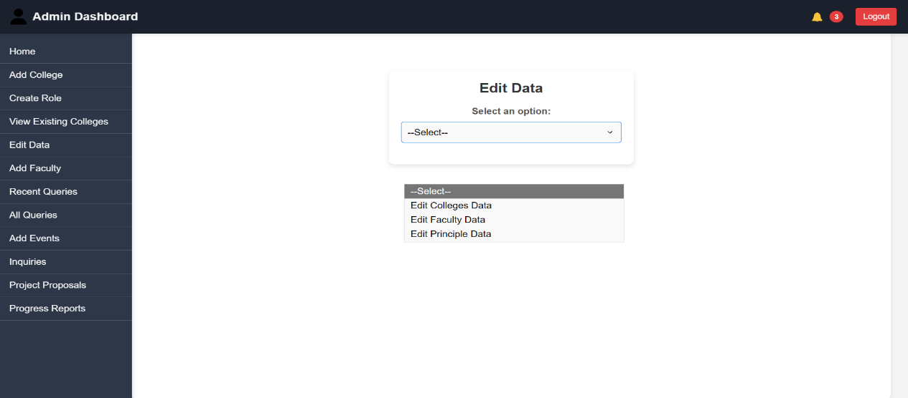

**V.Add Faculty:**

New Faculty details can be added.

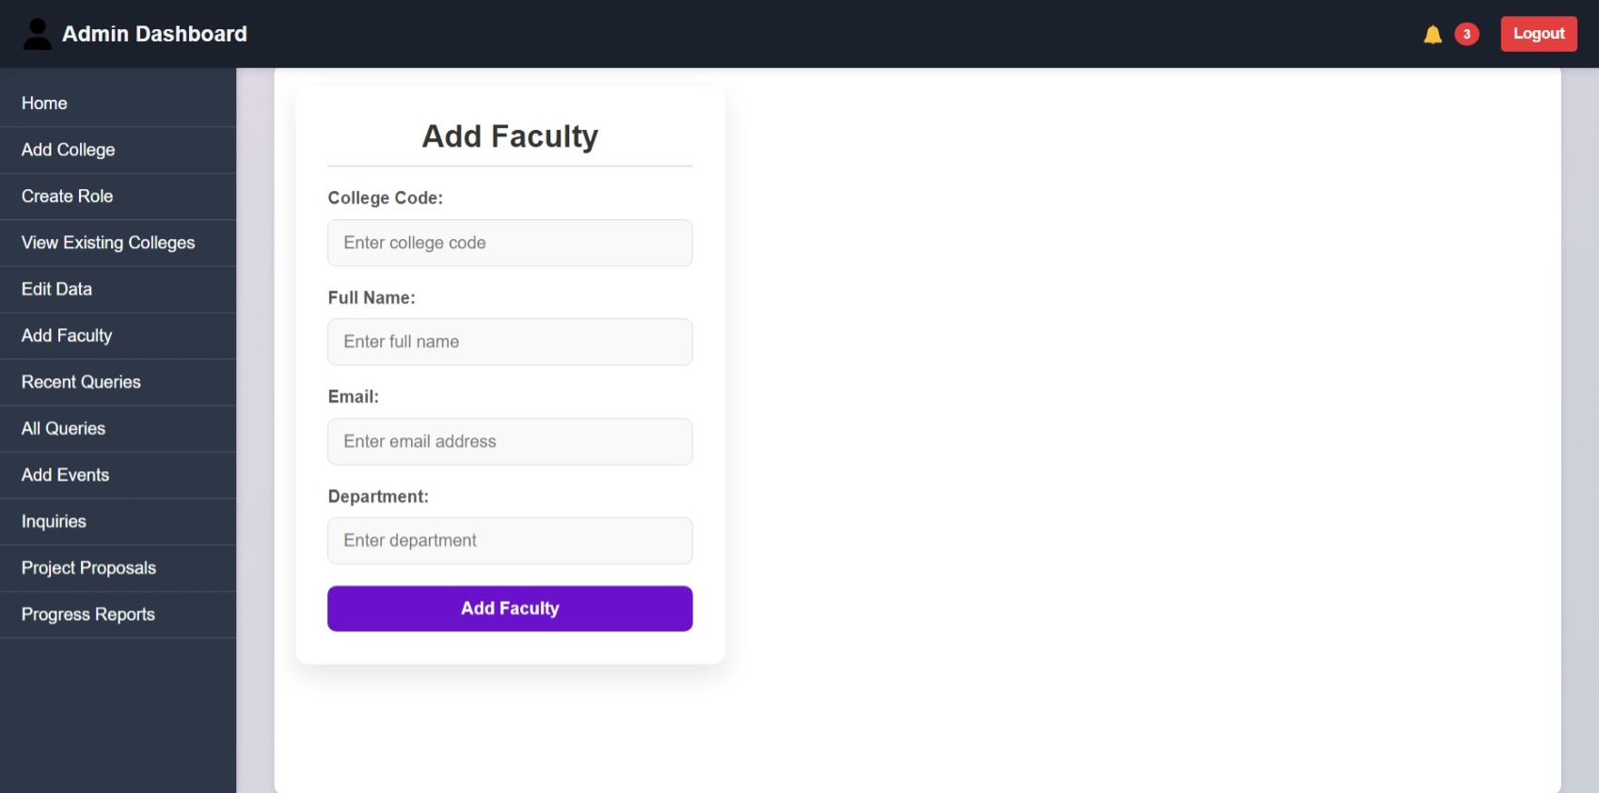

**VI.Recent Queries:**

In this section all proposed projects or ongoing or completed projects along with their current status and leader faculty id will shown up.

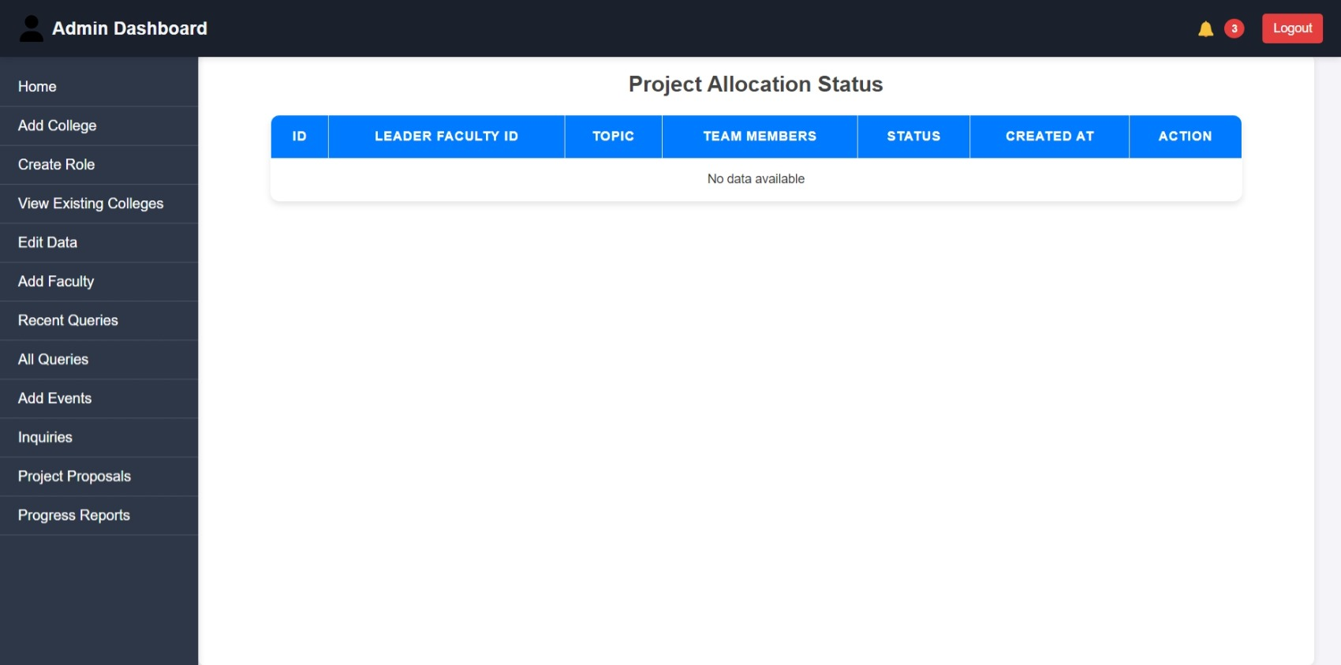

**VII. All Queries:**

Admin can give allocation permission (either ACCEPT or REJECT) to proposed projects.

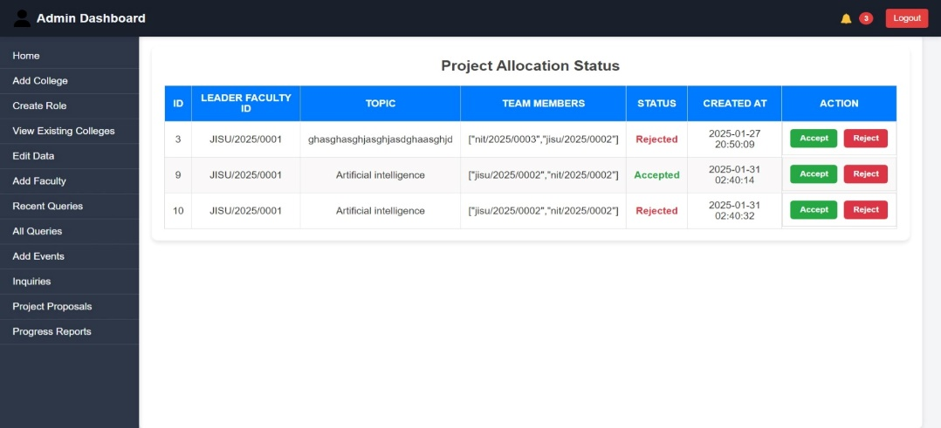

**VIII. Add Events:**

Can edit or add new events or notice in this section which will be shown In the main event page.

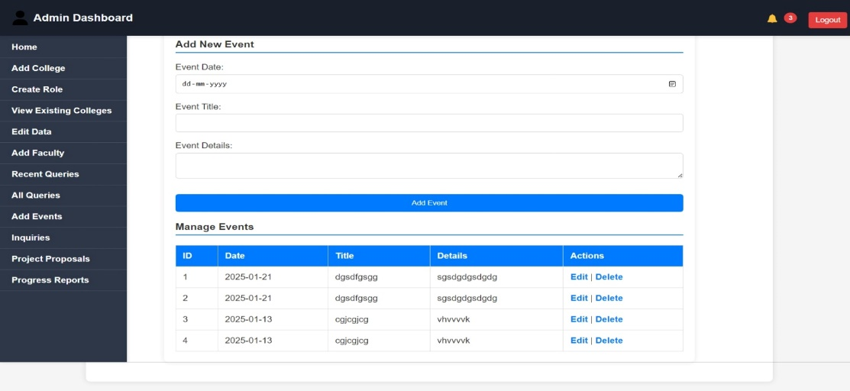

**IX. Inquiries :**

Whatever inquiries are received by inquiry form, the admin can reply to them from this section.

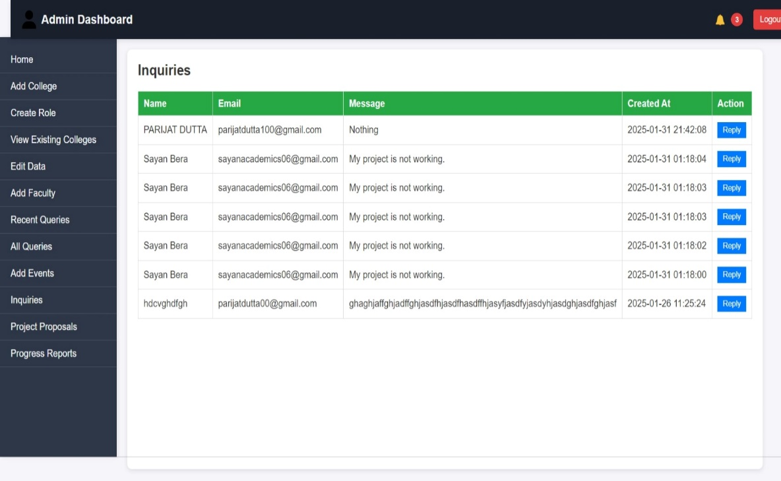

**X. Project Proposals:**

All proposed project details can be shown here along with their downloadable pdf file.

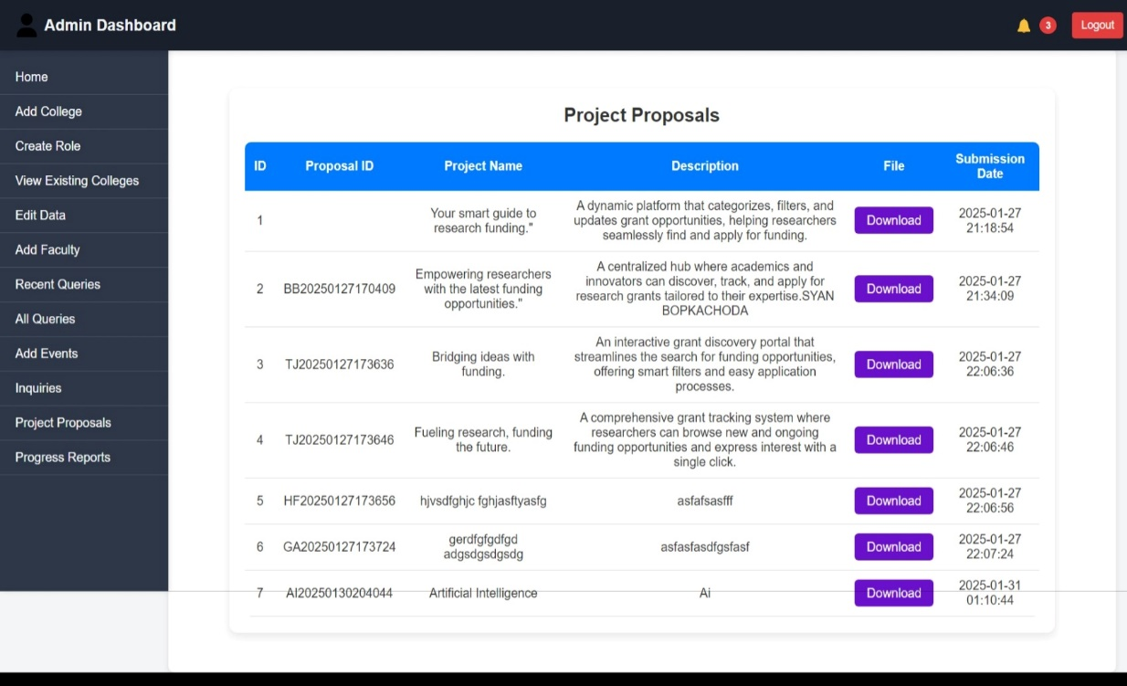

**XI.Progress Reports :**

Progress report details of each project will be shown here in this section.

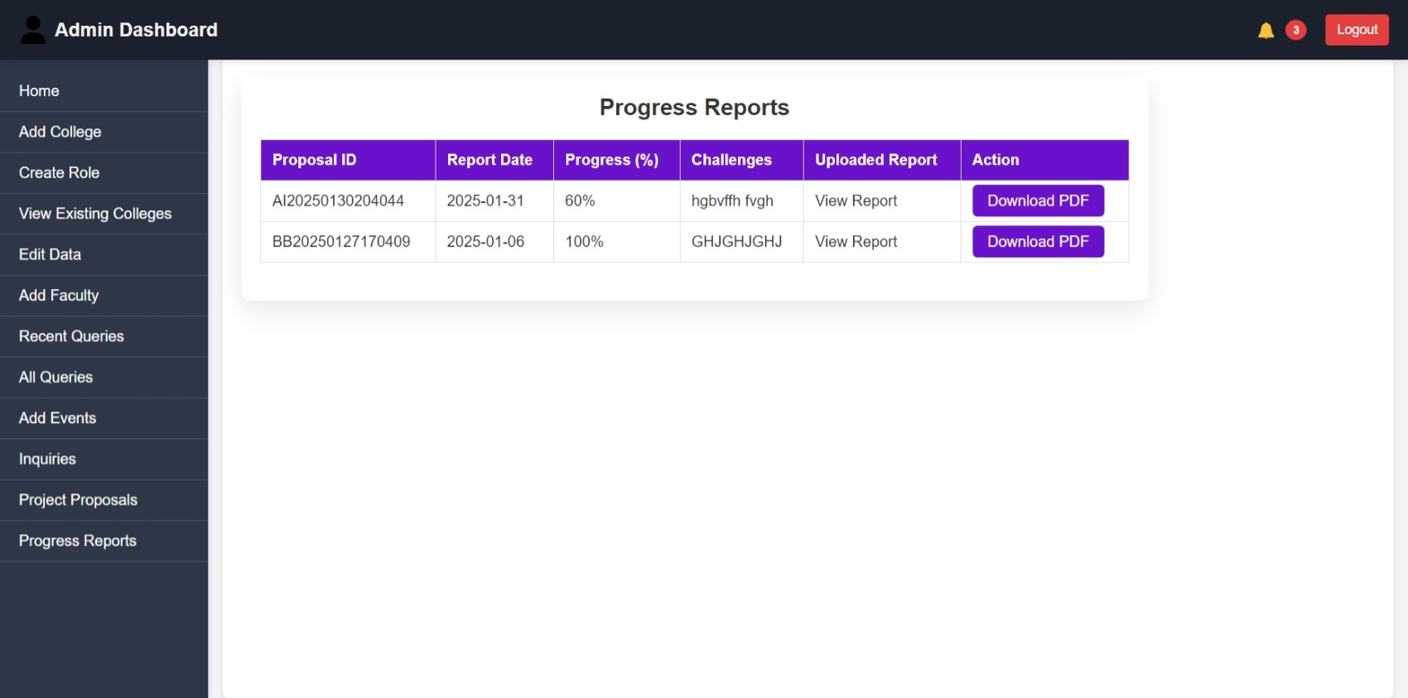

**4.1.2. Faculty login page:**

After logging in as Faculty, the FAculty dashboard will open including

1. Project Apply
2. Project Proposal submission
3. Progress Report
4. Edit My profile

**I.Project Apply :**

Faculty will apply for a project along with PROJECT NAME, TEAM MEMBERS’ NUMBER , NAME, and FACULTY_ID.

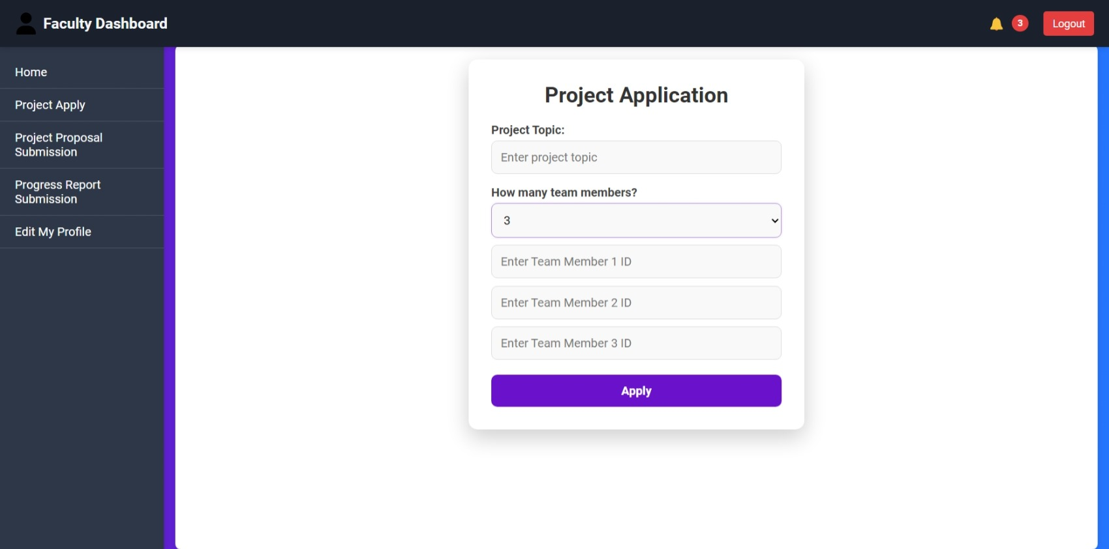

**II.Project proposal submission :**

Faculty can give details about their project name, and description along with report document.

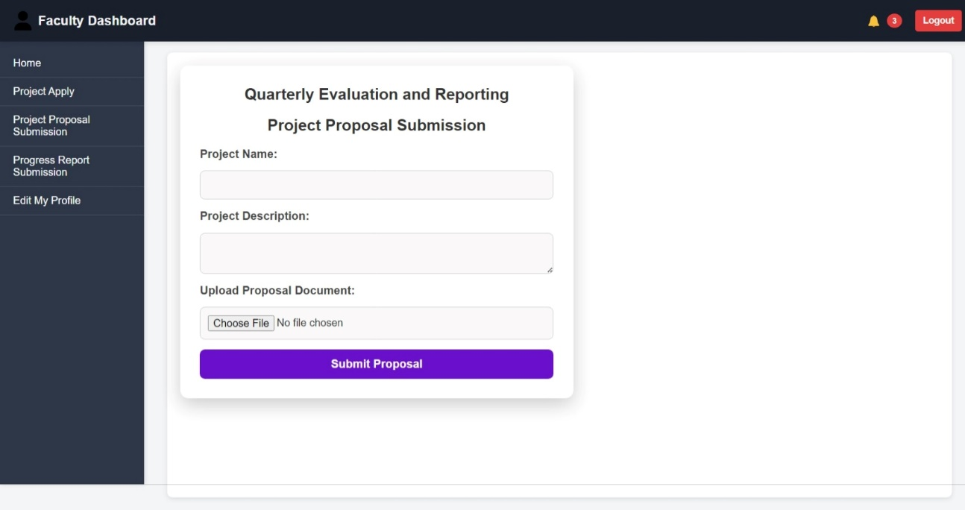

**III. Edit my Profile :**

Faculty can edit Their name, email id, department and also password for login .

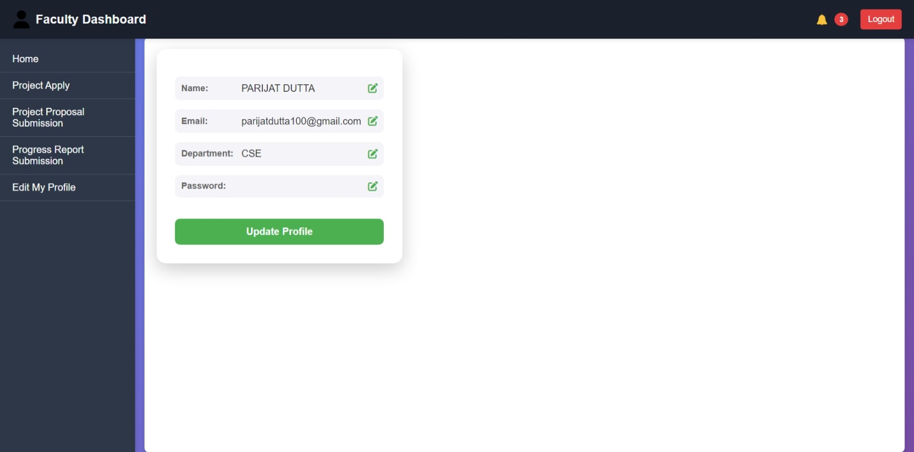

**5 Partner side :**

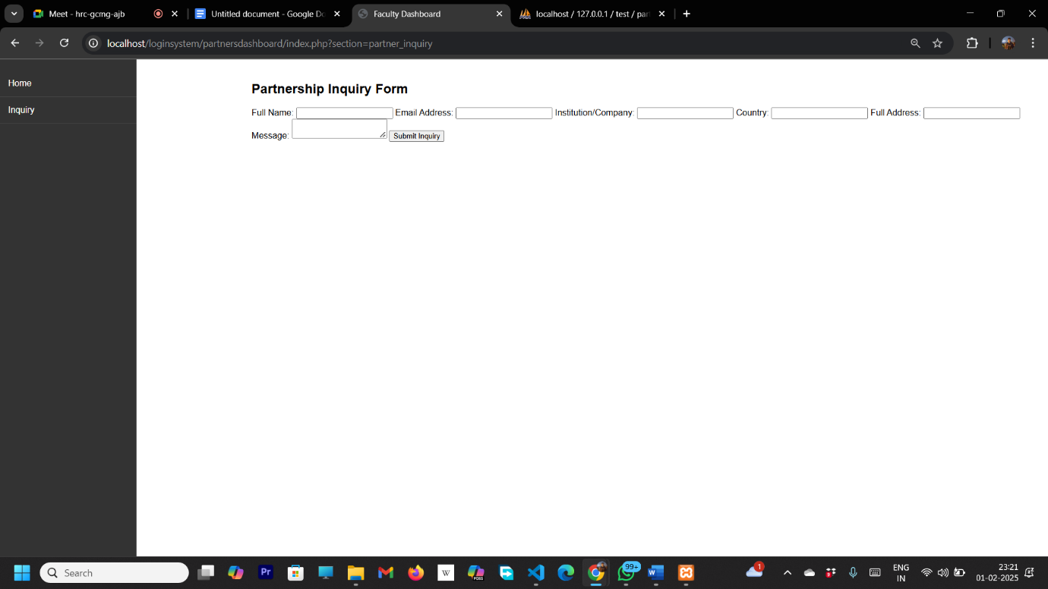

**5.2 Aboutus page:**

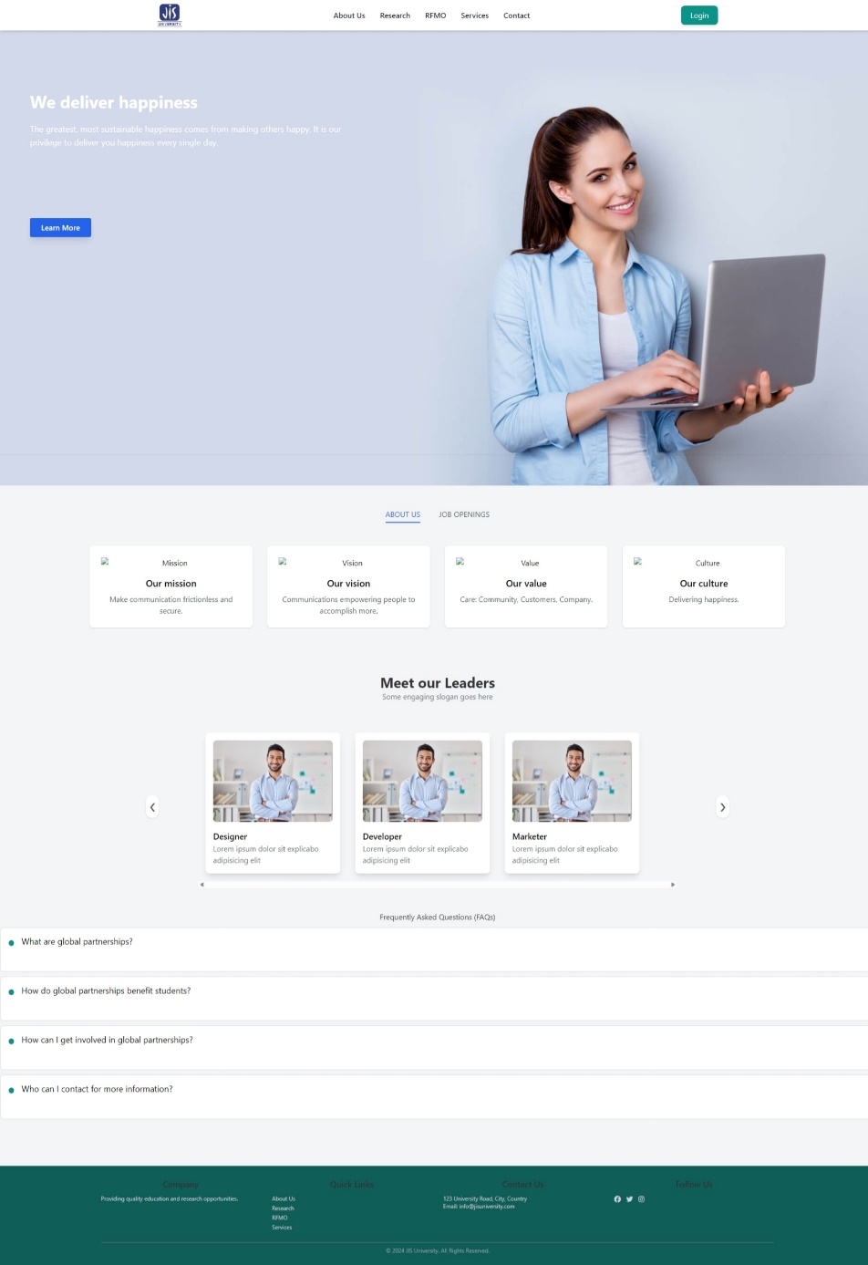

**5.3 Events page :**

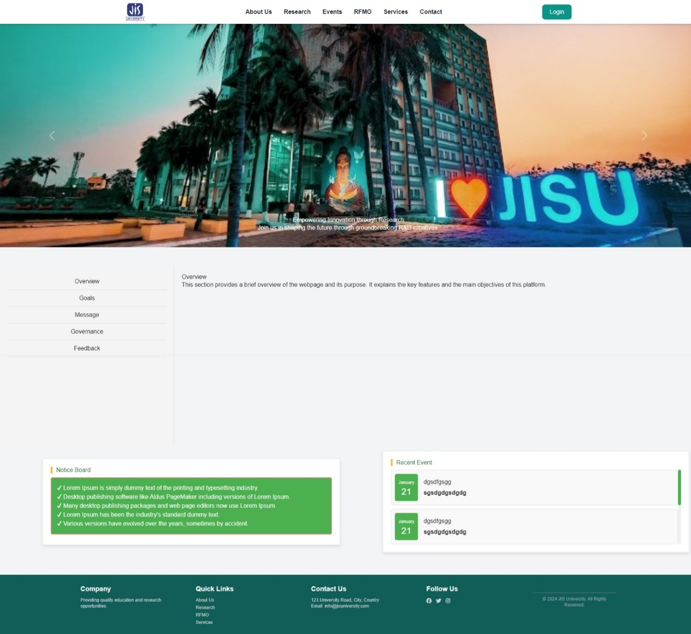

**5.4 Service page :**

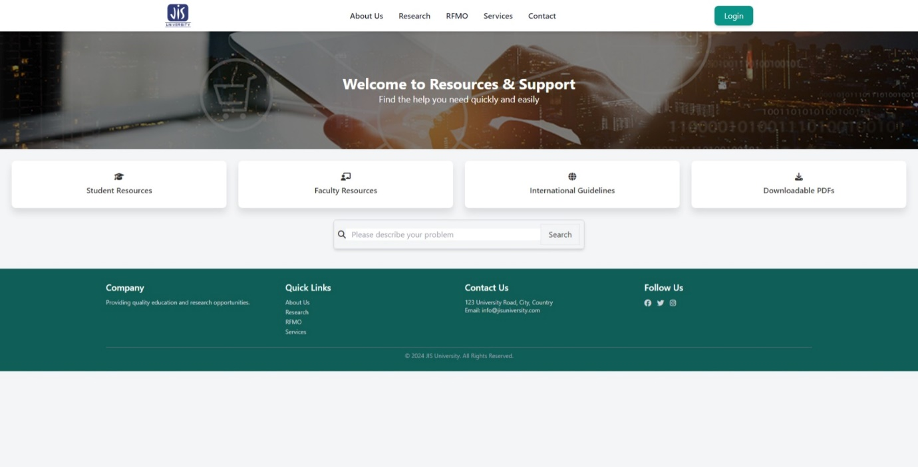

**5.5 RFMO page :**

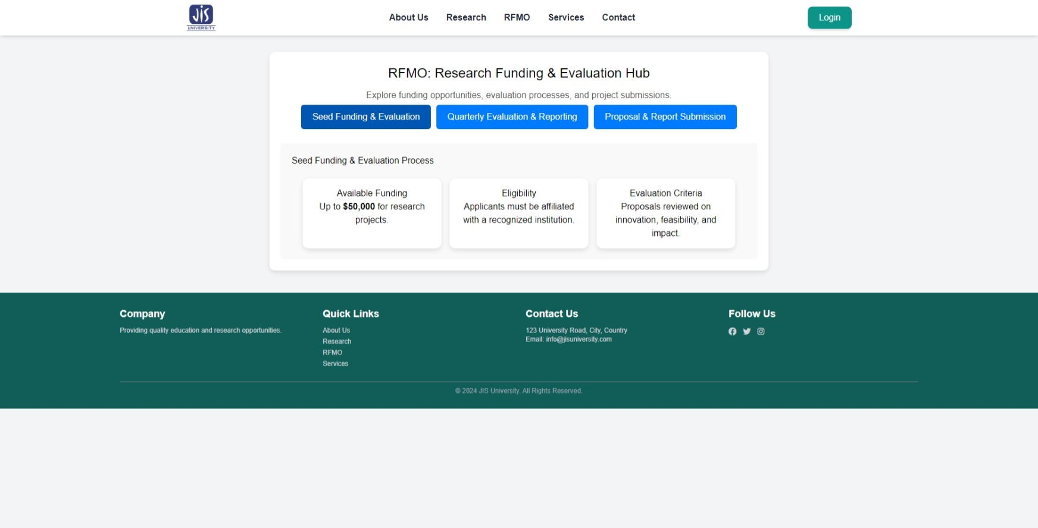

**5.6 Global Partnership:**

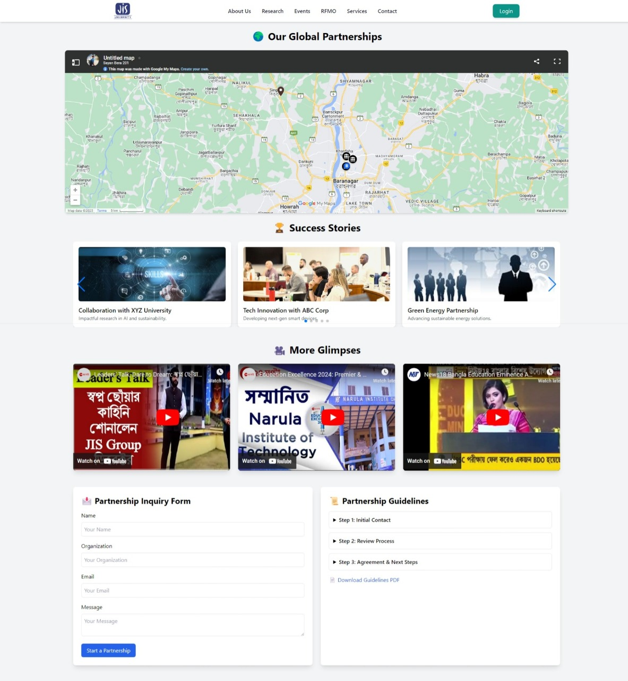

**5.7 Initiatives:**

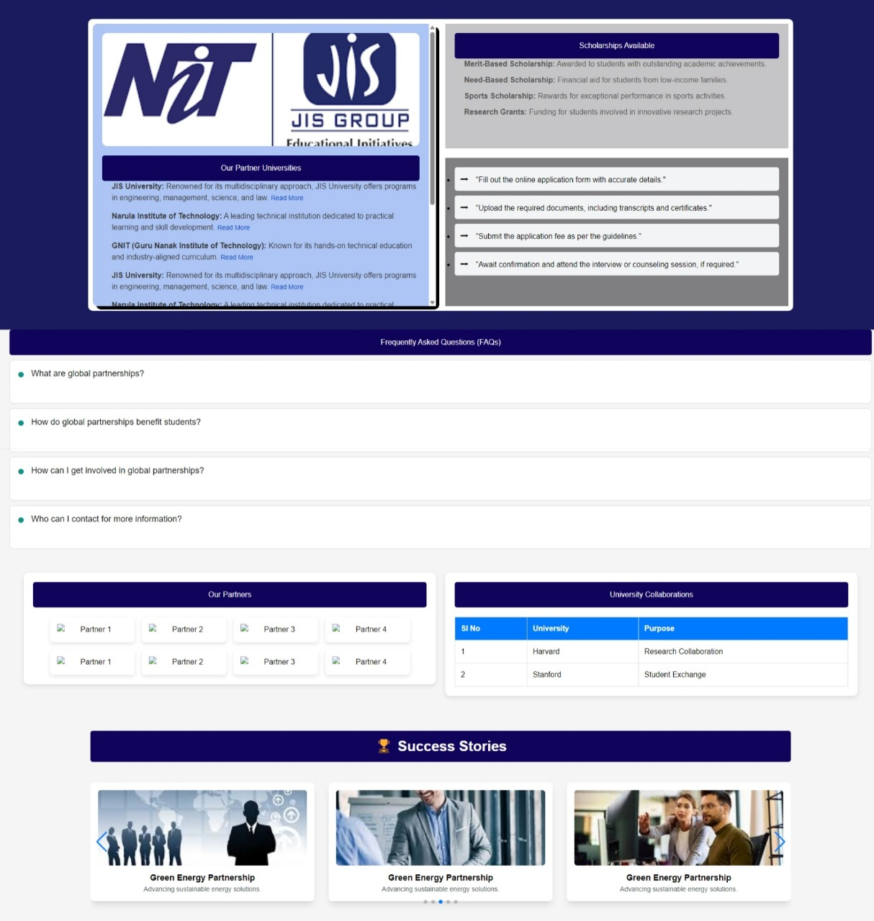

**6. Testing & Debugging**

Testing Methods Used:

1. Manual Testing
   * Functional Testing → Ensures that features like login, project submission, and grant tracking work as expected.
   * UI/UX Testing → Checks responsiveness, accessibility, and overall user experience.
   * Security Testing → Tests authentication, role-based access control, and data protection mechanisms.
   * Performance Testing → Measures load time, database queries, and API response times.
2. Automated Testing
   * Unit Testing → Uses tools like Jest (JavaScript) or PyTest (Python) to test individual components.
   * Integration Testing → Ensures APIs, database interactions, and frontend-backend communication work smoothly.
   * End-to-End (E2E) Testing → Uses tools like Selenium or Cypress to simulate real user interactions.